Understanding the Alabama Economic Freedom Act – The Alabama FairTax

The Alabama Economic Freedom Act, aka Alabama FairTax, is a new way to collect revenue for the state. It is a one-time consumption tax on all NEW goods and services; an inclusive tax that replaces ALL current state income and sales taxes, including individual, corporate, inheritance, gift, business-to-business taxes, and local sales taxes. Once an item is taxed, it is never taxed again. Used goods were already taxed when new and are never taxed again. An individual Alabama resident has no need to accumulate receipts for tax purposes and no need to fear audits from an Alabama income tax system. Finally, the AEFA is defined to be revenue neutral when enacted.

To better understand how the Alabama FairTax works, let’s take an example of a new item priced at $100 on the shelf. A consumer will only pay $100 for the item, which includes state plus county and municipal taxes. The state tax is $6.50 (6.5%) and the remainder is split between local governments based on actuals from the current system for a total of $2.05 (2.05%). Alabama has 67 counties and 440 municipalities collecting local taxes. The sum of these local taxes result in an overall collection of 2.05% of the revenue. For instance, Huntsville currently collects a 5.5% sales tax plus 4.0% state sales tax for a total of 9.5%. Under the new system, that total would be 6.5% state, 0.15% for Huntsville, and 0.031% for Madison County, or a total of 6.651%. Thus, when all of the taxes from counties and municipalities are added together, total revenue collections for the state equal 8.55%. This single rate consumption tax replaces ALL of Alabama’s current income/sales tax system.

Retailers will collect the tax and remit it to the state. They are paid for the collection and subject to audit by the state. The form retailers complete for tax remittance is short and based on inventory sold per collection period. Retailers will likely lower their prices because competition drives lower prices.

Farmers and businesses that sell products to other businesses incur no business-to-business tax. As an example, farmers pay no tax on farm machinery, seeds, etc., or labor required to produce their products. Sales of the farmer's products to other businesses for use in their products would not be taxed. However, a farmer who sells his product directly to a consumer at a farmer’s market or on the side of the road is responsible for collecting the tax. Taxes are only collected on end products sold at retail.

Because no legal Alabama resident should be taxed on the necessities of life, the Alabama FairTax includes a prebate (Family Consumption Allowance (FCA)) which is a monthly return of all taxes a person would pay up to the poverty level (see AEFA Prebate Schedule, pg. 2). A single person can spend up to $14,580 before effectively paying any state, county or municipal taxes. The prebate is issued to the head of household at the first of the month before any money is spent. In order to receive the prebate, a person must be a legal U.S. and Alabama resident, and annually complete the application form required of individual heads of household. The prebate is based on family size, not income. The form requires the name of the head of household and each legal dependent, address, and valid social security numbers for all. Receipt of the prebate is totally optional, and those who wish to remain anonymous simply do not need to apply for it.

The size of the prebate is based on Health and Human Services poverty level guidelines published at the beginning of every year. For 2023, $14,580 is the poverty level for a single person. A single legal Alabama resident would receive $79 monthly to cover the taxes to be paid on spending up to $1,215 that month. That means a single person could spend $1,215/month without incurring any state, county or local tax consequences. The prebate for a couple is twice that of a single person. For a family of four, a couple with two children, the poverty level is $39,440, and that family would receive $214/month on the first of every month.

The prebate eliminates the tax consequences for all legal Alabama residents up to the poverty level (see AEFA Effective Rate, pg. 2). For instance, a single person spending $14,580 or less per year is compensated for the consumption tax levied on that amount. If that person spends twice that amount, he will pay an effective tax rate of 3.25% on all purchases. To actually pay an effective tax rate near 6.5%, that person would have to spend more than $3.5 million!

The Alabama FairTax is a win for all Alabama residents. Some cities and counties have chosen to pay more local or county tax to raise funds for roads, schools, and other projects. With the Alabama FairTax everyone will pay 6.5% plus the local tax and any extra special taxes voted on by the community (see second paragraph). Everyone will have the chance to decide just how they think this tax will affect them, since a vote is required on a constitutional amendment to abolish Alabama’s current tax system. Alabamians will have a chance to speak with our legislators and let them know what we think about a total change in the way taxes are collected in our state.

For more information go to http://www.alfairtax.org  Mary Lynn Bailey  Alabama FAIRtax  maryly01@sprynet.com | Chuck Bailey  Alabama FAIRtax State Director  irlaserman@sprynet.com

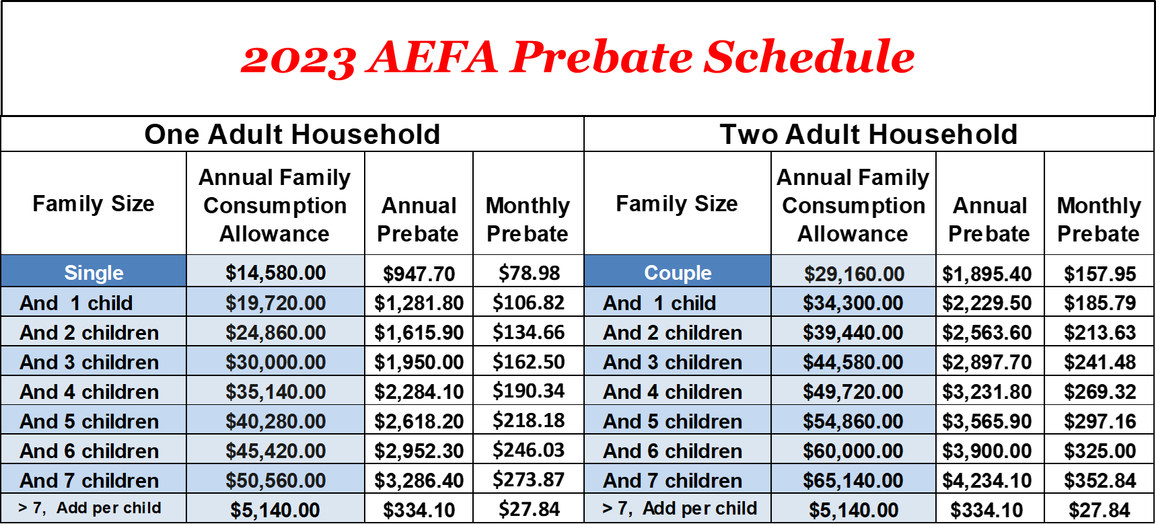 Note: Family Consumption Allowance = FCA = Poverty Level = Basis to Calculate Prebate

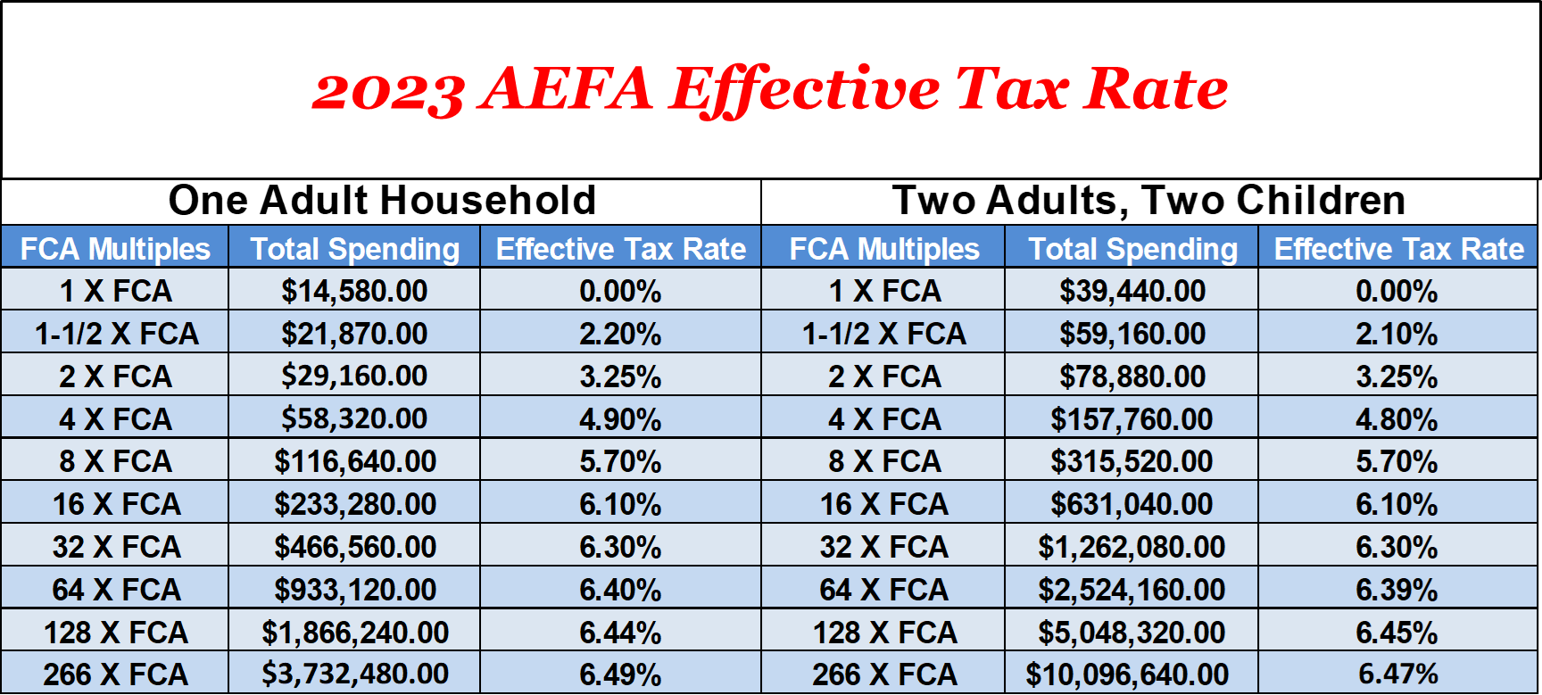
NOTE 1: Both schedules are based only on the state portion of the consumption tax. Since each city and county tax is different, the associated Prebate for them will vary across the state. Based on family size, distribution of the Prebate will contain the state and local taxes to cover the FCA for any given month.
NOTE 2: If you like the Alabama FairTax, you can let your legislators know at:
www.contactmypolitician.com.
Contact My Politician is a free, easy to use, resource to let your representatives know what you think on subjects that affect you.
